***Report On Hotel Booking Data Analysis***

**Analysis and Findings**

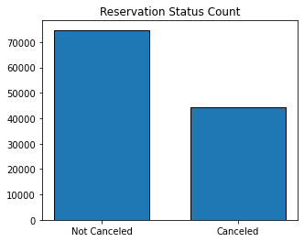

The bar chart shows the percentage of reservations that are cancelled and those that are not cancelled. There are significant number of reservations which are not cancelled but the percentage of cancelled reservations is 37% which has a notable impact on hotels’ earnings.

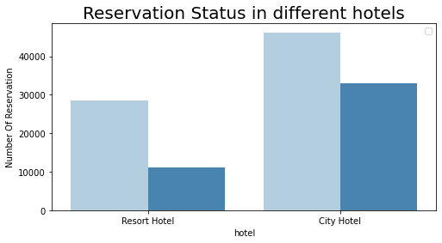

In comparison to resort hotels, city hotels have more bookings. It can be assumed that resort hotels are more expensive than those in cities.

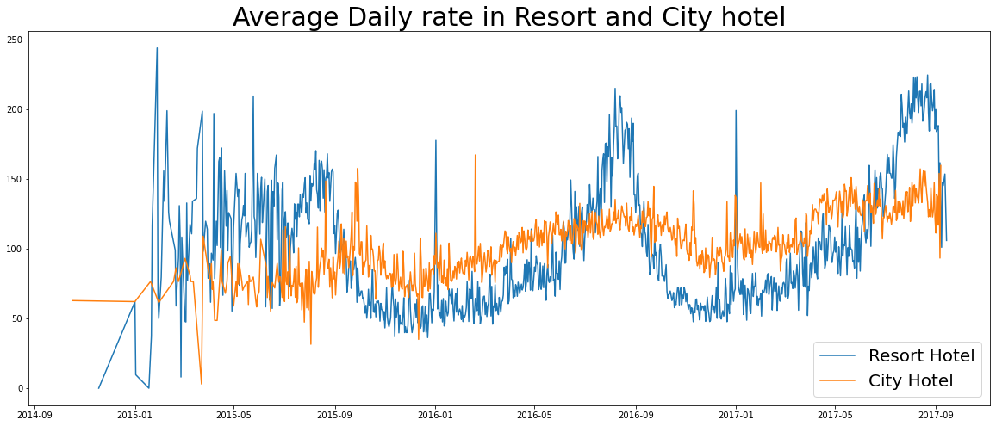

The line graph illustrates that the average daily rate for a city hotel is less that of a resort hotel and on other days,it is even less. Additionally,weekends and holidays may see a rise in resort hotels.

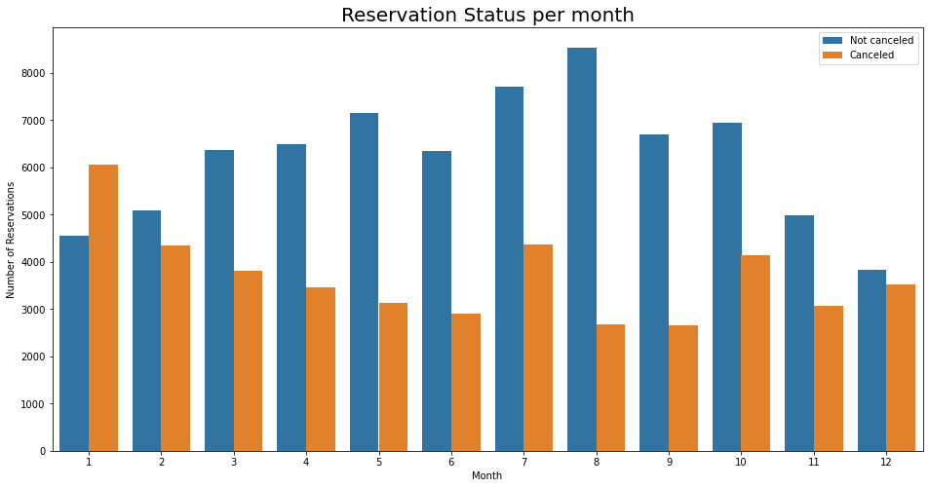

This graph is developed to analyze the months with the highest and lowest reservation levels according to reservation status. Largest number of reservations occurred in the month of August whereas January, experienced the most cancelled reservations.

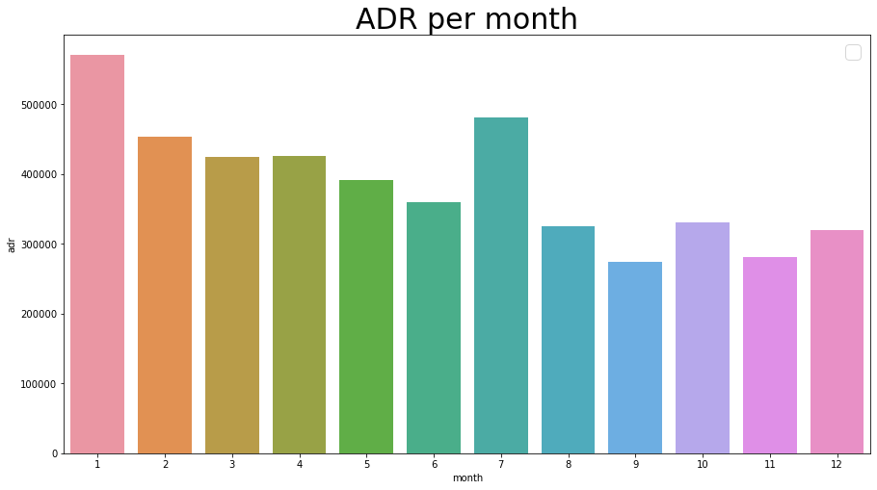

This graph demonstrates that cancellations are going high when prices are greater. When prices are lowest, cancellations are followed downward trend.

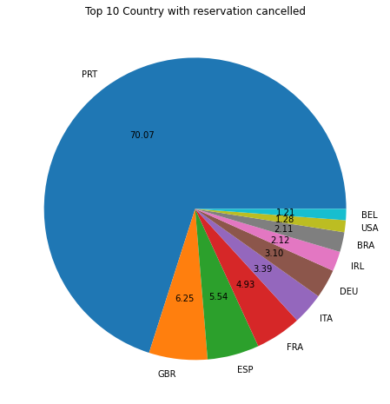

Top 10 country which is cancelled reservation. The top country Portugal with the highest number of cancellations.

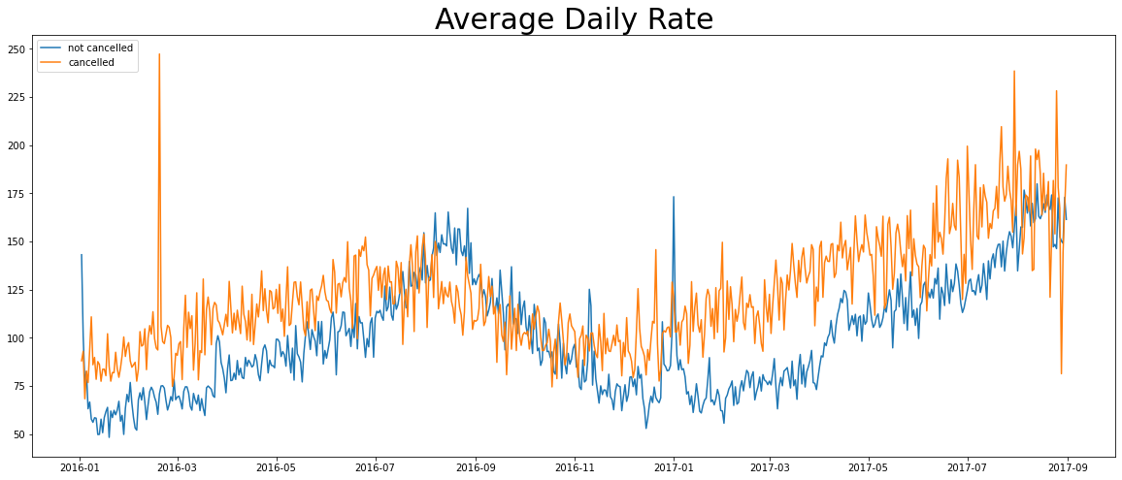

Let us check the area from where guests are visiting the hotels and making reservations. Is it coming from Direct or groups Online or Offline travel agents? Around 46% of the clients coming from online travel agencies, whereas 27% are from direct groups. Only 4% of the clients book hotels directly by visiting them and making reservations.

As seen in the group, reservations are cancelled when the average daily rate is higher than when it is not cancelled. We can clearly understand from the above analysis, the high price leads to higher cancellation.

**Suggestion**

1.Cancellation rates rise as the prices does. In order to prevent cancellations of reservations, hotels could work on their pricing strategies and try to lower the rates for specific hotels based on locations. They can also provide some discounts to the consumers.

2. As the ratio of the cancellation and not cancellation of the resort hotel is higher than city hotels. So, the hotels should provide discount on hotels room prices on weekends or on holidays.

3. In the month of January, hotels can start campaign or marketing with a reasonable amount to increase their revenue as the cancellation is the highest in this month.

4. They can also increases the quality of their hotels and their services mainly in Portugal to reduce the cancellation rate.